How ‘Wicked: For Good’ Prevails
in the Online Space
Group 43: Martin Plaskon (26107218), Shane Kelly (261011914), Stephanie Liu (261120386)
COMP 370: Introduction to Data Science

Introduction
In this project, our group attempted to examine the social media response and visibility of the newly released movie Wicked: For Good in comparison to other recently released movies. We focused on looking at posts from various subreddits on Reddit. The stakeholders specifically wanted to know which aspect of the movie was the focus of the Reddit post and how much coverage the movie received relative to other movies released at a similar time. Our pool of movies was: Wicked: For Good, Predator: Badlands, Sinners, Nuremberg, and Fantastic Four: First Steps. We found that the top 3 aspects of posts concerning Wicked: For Good were focused on reviews, release & distribution, and comparisons to other movies/franchises. Concerning the second question, we found that early discourse surrounding Wicked: For Good was heavily shaped by its position in the release cycle. It was shown that Reddit emphasized reviews and release-related information, rather than plot discussion/analysis. Although the movie received good attention relative to other movies in our dataset, its recent release date limited the number of posts concerning deeper topics and discussions. Our results and discussion conveyed to stakeholders what audiences were discussing, and why certain types of posts were more prevalent than others, depending on the stage of a movie’s release cycle.
Data
Our dataset consists of 500 Reddit posts in English from various movie-related subreddits. The subreddits included in our search are: r/movies, r/cinema, r/film, r/moviedetails, r/letterboxd, r/moviereviews, and r/moviecritic. The recently released movies included in our search are Wicked: For Good, Predator: Badlands, Sinners, Nuremberg, and Fantastic Four: First Steps. All of these movies have been released within a year, with the oldest being Sinners, which was released in April of 2025. The number of posts collected were 317 for Sinners, 69 for Predator: Badlands, 47 for Wicked: For Good, 38 for Fantastic Four: First Steps, and 30 for Nuremberg. One element to ensure that our movies were in our dataset was to add multiple keywords based on different formattings (ex. Fantastic 4: First Steps, Fantastic Four: First Steps; Wicked: For Good, Wicked For Good). This extra layer ensured that every single post in our dataset was related to one or more movies in our list. For every post, we extracted the title and body, excluding engagement metrics such as upvotes and comments. Some posts contained only titles and an image or external link as the body of the post, in which case only the title was taken into account for analysis. Another aspect of collecting our data was making sure posts were not outdated. In our initial pool of subreddits, there weren’t enough posts regarding our movies, resulting in some posts being as old as 10 years. We refined this by adding more movie-related subreddits, which made sure all posts were recent, with the oldest post being from 7 months ago. This also helped rectify the problem that the movie Nuremberg had an older version as well, so these recent posts had a higher likelihood of being based on the recently released version. A problem we ran into was when we used r/boxoffice in our pool of subreddits. When used, our search contained a very large amount of posts which all had the same topic (box office & industry) due to the nature of the subreddit (whereas other subreddits had a mix). This offset the data and we realized that removing it was the best balance.

Methods
The initial approach we took involved using the JSON Reddit url for the ‘new’ tab of each checked subreddit. This quickly resulted in an issue where the script was returning significantly less results than expected. This ended up being due to the fact that the new JSON only tracks the most recent 1,000 posts, not tuned to the posts involving our keywords. In some high volume subreddits this is not sufficient to grab all recent data on these movies. The decision was then made to switch to using a series of dynamic JSON URL calls that cycled through each subreddit and keyword. The queries were modified using ‘q={query}’ where query was the current keyword being searched, ‘sort=new’ ensuring the most recent posts were prioritized, ‘limit=100’ to return more posts per request, and ‘after={after}’ where {after} connects to a variable that handles tracking for pagination. This combined to account for the fact that the maximum a single call will return through Reddit is 100 posts, and our need to account for the possibility that more than 100 posts may be returned for a search. Cycling through each keyword for each subreddit risks returning many more posts than the required 500, and so we had a variable set of a larger number that the script will collect, before building the 500 posts output based on the most recent posts of the complete list. This was to negate any bias introduced by the order that the keywords are searched, as if the keywords relating to Wicked are the first search, returns 500 results, then terminates, then, of course, the data will show only Wicked posts. Finally, it is essential to note that time delays were incorporated between each call to ensure the ethical collection of this data. While this did mean it took some time to gather all the data, it was necessary in this case since we were using the url JSON requests and not using the Reddit API.

After collection and annotation, we constructed each post’s title and body into a unified text field for topic characterization. It is worth noting that some posts contained only a title alongside an image, meme, or an external link as body. In these cases, only the title text was preserved. Additionally, we excluded comment threads to prevent jokes, conversational back-and-forth, or off-topic digressions from disproportionately shaping topic word distributions. After basic normalization, we grouped posts by their manually assigned topic and merged all texts within the same topic into a single “topic document”, resulting in seven input documents for TF-IDF computation. We then used scikit-learn’s TfidfVectorizer to compute discriminative terms within each topic. After an initial run, we manually inspected the top-ranked terms and noticed several high-ranking terms that were not relevant to our purposes. These included artifacts from URLs (“www”), random numbers (“11”, “13”), franchise-specific referents that leaked across categories (“oz”, “wizard”, “vampire”), and multiple terms that had the same exact meaning but were in a different tense (“feel” and “feels” made it to the top in the reviews category; “feel” was kept, whereas “feels” was filtered out). To address this, we constructed a small custom stopword list and filtered those terms out after computing TF-IDF, so that the underlying statistics remained reproducible and the removal was easy to document. The final output was a CSV listing, for each topic, the 10 terms with the highest TF-IDF values and their scores and ranks.

Finally, to obtain qualitative characterizations of each topic, we exported the posts for each topic and provided them to an LLM (ChatGPT) with a standardized prompt. The prompt instructed the model to summarize only the posts within that topic, avoiding comparisons across topics or movies, and to use an academic tone in 2-4 sentences. This produced one representative summary per topic, which we report alongside the TF-IDF terms in the Results section.
Results
Our group was able to form a typology including 7 topics. These topics are: reviews, release & distribution, plot discussion, production, comparison, box office & industry, and cast & crew. An LLM (ChatGPT) generated a summary of these 7 topics as follows:

1. Box Office & Industry
Discussion in this topic centers on financial performance, opening-weekend results, and week-to-week box-office trends. Users track record-breaking debuts, unusually strong holds, comparisons among competing releases, and speculation about profitability. Many posts also note awards positioning, franchise impacts, and whether certain films signal broader shifts in the industry.

2. Cast & Crew
Posts focus on actors’ performances, behind-the-scenes insights, and professional trajectories of cast members and directors. Users highlight standout acting moments, breakout roles, award recognition, and anecdotes shared in interviews or AMAs. They also discuss casting news, cameo appearances, and technical contributors such as composers and cinematographers.

3. Comparison
This category consists of users comparing films in terms of box-office potential, narrative quality, genre approach, or personal preference. Discussions often evaluate how one movie stacks up against another, whether certain entries surpass predecessors, and how stylistic or thematic elements differ across works. Tone ranges from analytical to subjective, with comparisons used to articulate expectations and judgments.

4. Plot Discussion
Users analyze story elements, character motivations, thematic choices, and world-building details. Many posts debate specific scenes, interpret symbolic devices, question lore consistency, or explore potential sequels or spinoffs. The tone is highly interpretive, reflecting both clarification-seeking and deeper thematic engagement with the narrative.

5. Production
Posts emphasize filmmaking craft, including cinematography, visual effects, music, costume design, and directorial choices. Users comment on practical challenges, aesthetic decisions, behind-the-scenes processes, and influences that shaped the film’s style. Technical contributors, such as composers, cinematographers, and designers, receive notable attention, with praise for their execution and artistry.

6. Release & Distribution
This topic covers marketing materials, release formats, special screenings, and distribution strategies. Users discuss posters, trailers, IMAX or 70mm releases, streaming dates, and regional accessibility. Several posts also describe theatrical viewing experiences, audience reactions, and concerns about the potential for spoiler-heavy marketing.

7. Reviews
The posts capture a wide range of viewer responses, from highly enthusiastic to strongly critical. Users evaluate acting, writing, pacing, genre execution, cinematography, and thematic depth, often noting specific strengths such as music and visual style or weaknesses in narrative coherence. Sentiment varies widely, creating a mixed but engaged landscape of opinion.

Our dataset comprised 500 Reddit posts that mention the five selected films. Figure 1 shows the number of posts associated with each movie. Sinners received by far the largest volume of discussion, with 317 posts, accounting for the majority of the dataset. Predator: Badlands appeared in 69 posts, while Wicked: For Good accounted for 47 posts. Fantastic Four: First Steps and Nuremberg generated the least discussion, with 38 posts and 30 posts, respectively. Together, these counts establish the overall distribution of Reddit attention across the selected films during the sampling window.
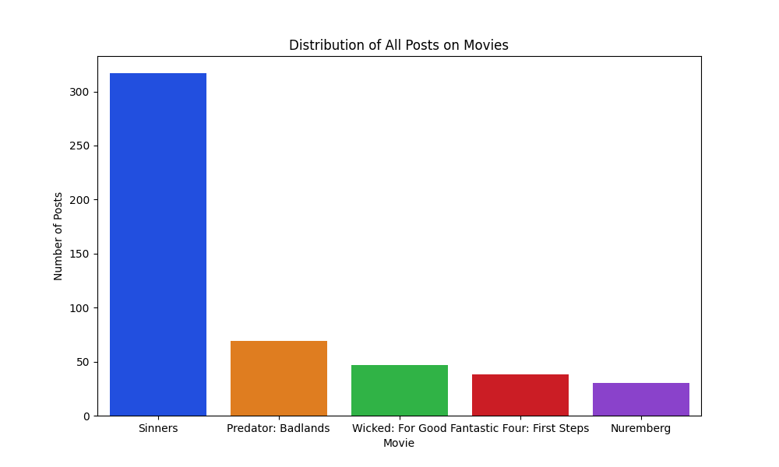
Figure 1: Distribution of All Posts on Movies

We then examined how topics were distributed within each individual film. Figure 2 presents topic frequencies for Wicked: For Good. The most frequent topic in this subset was reviews, representing 28% of the posts. This was followed by release & distribution (23%), comparison (17%), box office and industry (15%), and cast & crew (11%). Less frequent topics included production (4%) and plot discussion (2%), each accounting for a smaller portion of Wicked-related posts. These counts summarize how discussions for this specific film were distributed across the 7 topics.
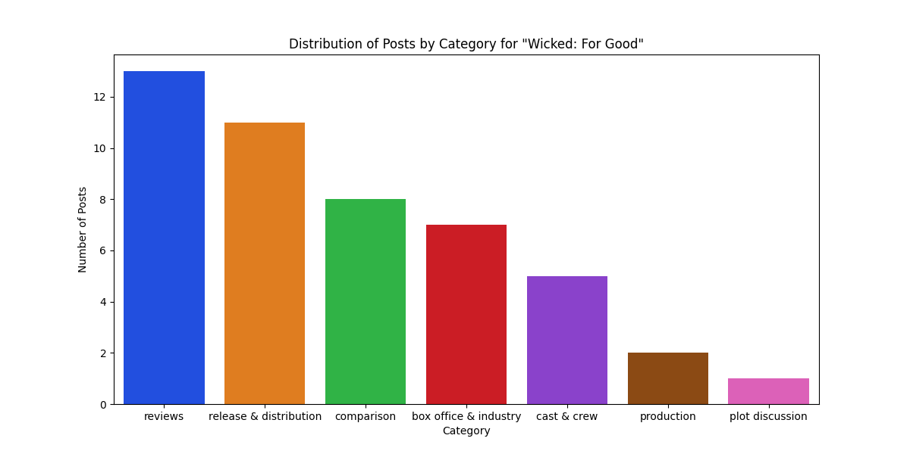Figure 2: Distribution of Posts by Category for “Wicked: For Good”

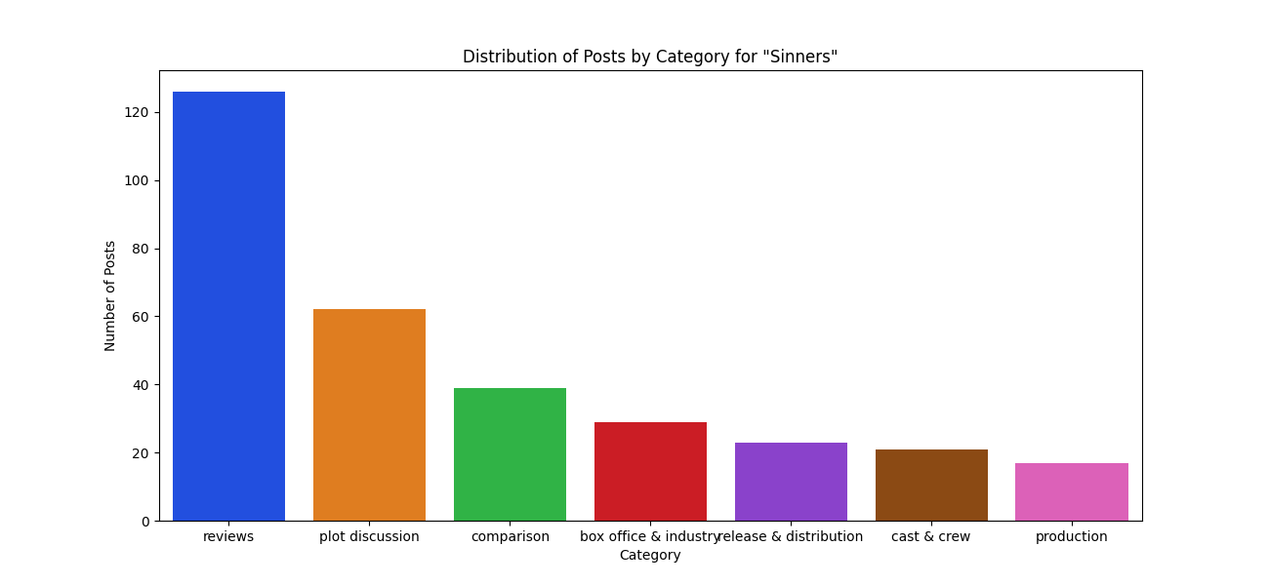
Figure 3 displays the topic distribution for Reddit posts on Sinners, the oldest film and the film with the largest share of discussion in our dataset. The most frequent category for this movie was reviews, accounting for 40% of Sinners-related posts. This was followed by plot discussion, which accounted for 20% of the discourse. Additionally, there were posts relating to comparison (12%), box office & industry (9%), and release & distribution (7%). Smaller but notable clusters included cast & crew (6%) and production (5%). Together, these values quantify how users discussed Sinners across the 7 categories and provide a reference point for comparing topic engagement across newer releases such as Wicked: For Good.
Figure 3: Distribution of Post by Category for “Sinners”

Figure 4 shows the overall topic distribution of posts across the entire dataset. Reviews were by far the most common topic, accounting for 39% of all posts. The next largest topics were release & distribution, and plot discussion, each accounting for 14% and 13% of the discussion on these movies. Smaller but still substantial clusters emerged around "comparison" (11%) and "box office & industry" (9%). Production and cast & crew were the least frequent topics, with them being, respectively, 8% and 5% of the discourse on these movies. These distributions quantify how Reddit users divided their attention across high-level aspects of the selected films.
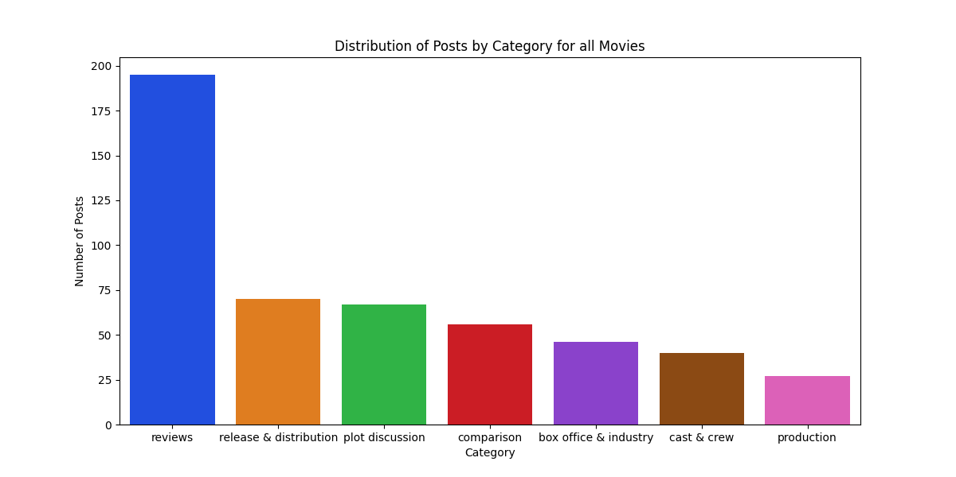Figure 4: Distribution of Posts by Category for all Movies

To characterize each topic linguistically, we applied TF-IDF to the concatenated text of all posts within each category. For every topic, we extracted the 10 highest-scoring terms. The top TF-IDF terms for each of the 7 categories are shown in Tables 1 and 2 below.

Box office & industry |  | Cast & crew |  | Comparison |  | Plot discussion
million | 0.875 | actor | 0.188 | say | 0.169 | stack | 0.300
weekend | 0.173 | ask | 0.165 | want | 0.141 | remmick | 0.260
worldwide | 0.132 | star | 0.163 | better | 0.131 | smoke | 0.185
debut | 0.125 | sarah | 0.159 | love | 0.131 | sammie | 0.181
total | 0.125 | youtube | 0.141 | feel | 0.112 | irish | 0.178
earned | 0.124 | questions | 0.136 | act | 0.110 | music | 0.120
drop | 0.100 | announcement | 0.136 | great | 0.103 | question | 0.110
domestic | 0.080 | ariana | 0.124 | second | 0.094 | juke | 0.103
office | 0.055 | directed | 0.124 | cinematic | 0.086 | want | 0.084
audience | 0.055 | year | 0.124 | felt | 0.086 | kkk | 0.079
Table 1. Top 10 words with the highest TF-IDF scores for Box office & Industry, Cast & crew, Comparison and Plot Discussion

Production |  | Release & distribution |  | Reviews
music | 0.298 | official | 0.435 | review | 0.215
soundtrack | 0.170 | poster | 0.410 | music | 0.172
score | 0.170 | rating | 0.231 | comments | 0.172
old | 0.149 | pg | 0.145 | great | 0.166
image | 0.128 | price | 0.121 | felt | 0.160
use | 0.128 | 70mm | 0.113 | feel | 0.149
test | 0.115 | teaser | 0.113 | character | 0.131
screenings | 0.115 | experience | 0.105 | reddit | 0.122
masterful | 0.115 | twist | 0.097 | old | 0.102
pale | 0.115 | featuring | 0.085 | love | 0.090
Table 2. Top 10 words with the highest TF-IDF scores for Production, Release & Distribution and Reviews
Discussion
In this discussion section, we aim to address both the questions from stakeholders. The first question was which aspects of the movie were the topics of the post, as well as which were the most common. As mentioned in our results, we found that posts about movies went into 7 different categories: reviews, release & distribution, plot discussion, production, comparison, box office & industry, and cast & crew. From our Figure 2, we can see that posts concerning reviews and release/distribution were the most popular. Topics concerning production and plot discussion were the least common. This suggests that the population on these subreddits was interested in the movie both before and after its release, but not necessarily in aspects like the plot and production.

One interpretation of this pattern is that online discussions tend to follow the chronological experience of a film release. Before and shortly after a movie comes out, users do not yet have shared knowledge of plot details or filmmaking choices. Because Wicked: For Good had only been released a few days before our sampling, most users were still in an early “impressions and access” phase, where it is safer and more common to discuss trailers, posters, release formats, and spoiler-light reactions rather than dissecting key scenes. Deeper conversations about narrative structure or production decisions require not only that a critical mass of users has already seen the film, but also that they feel comfortable discussing spoilers publicly. In contrast, Sinners, released months earlier, saw a greater proportion of posts on plot discussion (19.5%) and a smaller share of release & distribution posts (7.3%), while still maintaining a similar high proportion of reviews (39.7%). This supports the idea that plot and production-focused engagement tend to emerge later in the conversation cycle.

Looking at the overall distribution across all films (Figures 2 to 4 and other figures not included in this report), we notice that reviews are the largest category both collectively and individually across every movie. This may reflect the general culture of Reddit, where users go on there to share personal reactions, opinions, and long-form impressions after watching a movie. Additionally, many reviews naturally blend multiple aspects of a film in a single post. A user might discuss cinematography, music, pacing, and box office results while still delivering a sentiment-driven message. In such cases, these posts were categorized as reviews because their primary purpose was evaluative. Thus, the dominance of reviews likely reflects both user behaviour and the fact that the most opinion-driven writing tends to incorporate multiple thematic elements, especially for users who have fully watched the movie.

It is also worth noting that Wicked: For Good is the second part of a two-part adaptation, released roughly a year after the first. Thus, expectations, comparisons and pre-existing emotional investment are already high. This is reflected in the presence of comparison posts (17%), where users explicitly contrast the sequel to the first film in terms of tone, pacing and creative choices. At the same time, spoiler sensitivity as well as the fact that there have been many adaptations over the years (plot might therefore already be known) might suppress early plot discussion (2%). For stakeholders, this implies that early Reddit conversations around Wicked: For Good are not mostly about the plot itself, but are about its release as a continuation of an existing franchise

Secondly, stakeholders were also interested in “how much coverage the movie received relative to other movies that came out at a similar time”. From Figure 1, we can see that the largest number of posts across all subreddits was about Sinners, followed by Predator: Badlands, Wicked: For Good, Fantastic Four: First Steps, and Nuremberg. Accounting for only 9.4% of the dataset, Wicked: For Good is outshone by the number of posts about Sinners. This is, unfortunately, partly due to the fact that although all movies were released within the past six months, Sinners has had more time to establish itself in the online space, whereas all the movies, except Fantastic Four: First Steps (released in July), were released in November. This realization occurred a bit too late in the project's process, but it came with important insights.

A key insight for stakeholders is that “recently released” is not a neutral category when comparing online attention. Our findings suggest that a film’s online presence is strongly shaped by how long it has been in circulation. Older releases such as Sinners benefit from compounded discourse: reviews have time to accumulate, plot discussions become possible without spoiler concerns, and industry narratives (e.g. award placements, box office milestones) mature over time. In contrast, films that were released shortly before or during our data collection were disproportionately represented by marketing-driven content. This is reflected by the dominance of “release & distribution” discussions in Wicked: For Good (23%) and Predator: Badlands (28%), where users referenced trailers, posters, formats, and media campaigns rather than evaluating the film itself. These movies, as a result, have fewer overall posts than their counterparts due to factors such as longevity and marketing, among others.

However, the comparatively low engagement with Fantastic Four: First Steps and Nuremberg highlights that visibility alone does not translate into discussion volume. Both films were accessible during our sampling window, with Fantastic Four: First Steps being released four months prior to the others (excluding Sinners) and Nuremberg, around the same time as the others (excluding Fantastic Four: First Steps and Sinners), yet neither developed an extended discourse on Reddit. This may suggest limited marketing impact, cultural traction, or franchise relevance, which are possibilities that would be valuable for industry stakeholders to explore further. For Wicked: For Good, this means its relatively modest presence is not necessarily indicative of poor reception, but rather, it has not yet reached the phase where conversation deepens into sustained narrative and comparison-driven interest. Stakeholders should expect that, if engagement continues to build, categories such as reviews and comparisons (already 28% and 17% of Wicked-related posts) will likely expand further over time, and thus possibly increase their coverage relative to other movies in our pool.

Finally, our topic characterization reinforces that Reddit’s interest is shaped by phases of the release cycle. Production-oriented and plot-oriented categories only emerge substantially after audiences have viewed a film and had time to interpret or critique it. This means that, for newly released films such as Wicked: For Good, stakeholders should expect disproportionate attention to marketing materials and promotional visibility until enough viewers have seen the movie to sustain deeper engagement. Overall, the findings indicate that Reddit provides a strong pulse on both immediate reception (via reviews and distribution talk) and long-term cultural traction (via comparisons, box office narratives, and plot analysis). For Wicked: For Good, this means its current discourse reflects early-cycle engagement rather than long-term impact. Therefore, interpreting online attention requires not just counting the number of posts, but considering where a film is in its lifecycle and which types of engagement are currently feasible for audiences.

Group Member Contributions
The work breakdown was divided among the three members as follows.
Shane handled the data collection by developing and running each iteration of the movie finding and TSV building scripts. Participated in the open coding process by annotating the 200 posts in that dataset. Wrote the methods section of the final report.
Marty helped refine the theory behind the data collection, such as noticing the problem with r/boxoffice, as mentioned in the Data section. Participated in the open coding process by annotating the 200 posts in that dataset. Wrote the Introduction and Data section of the report. Created figures to use in the results section using matplotlib in Python. Wrote the beginning part of the discussion section.
Stephanie participated in the open coding process by annotating the first 200 posts in the dataset, and manually annotated the set of 500 posts. Handled the TF-IDF computations and LLM-generated summaries of the 7 topics. Built tables for the top TF-IDF words in each category. Wrote the results section and parts of the methods and discussion sections of the report.

